**Conservation of Angular Momentum**

[Adapted from PASCO Lab Manual #39]

**Pre-lab questions**

1. What is the goal of this experiment? What physics and general science concepts does this activity demonstrate?
2. What is the mathematical expression for conservation of angular momentum?
3. What is the rotational inertia (moment of inertia) for a disk? How does this differ from a thick ring?
4. Do you expect rotational kinetic energy to stay the same, or increase, or decrease during this experiment? Justify your answer.

The goal of the experiment is to explore conservation of angular momentum.

**Equipment:**

* Rotary motion sensor
* Rotational accessory
* Large rod base
* 45-cm rod
* Calipers
* Level
* Balance

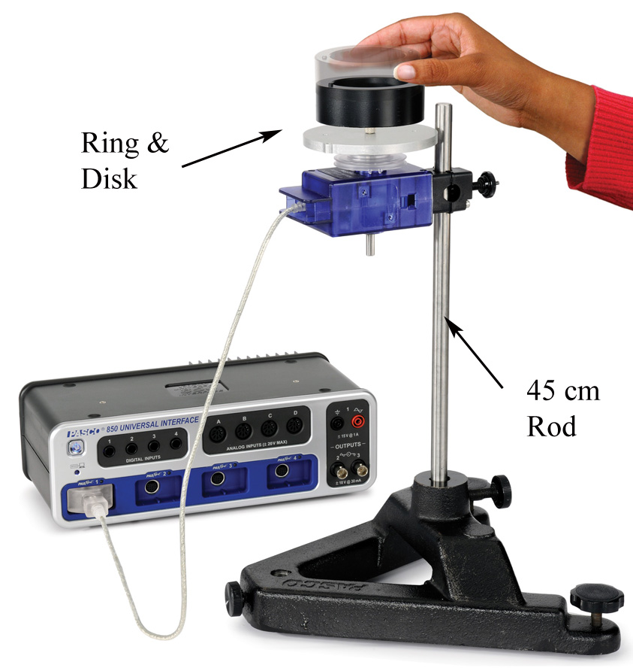

Figure 1: Conservation of angular momentum disk

**Introduction:**

A non-rotating ring is dropped onto a rotating disk. The angular speed is measured (by the Rotary Motion Sensor) immediately before the drop and immediately after the ring stops sliding on the disk.

The initial angular momentum is compared to the final angular momentum, and the initial kinetic energy is compared to the final kinetic energy.

When the ring is dropped onto the rotating disk, there is no net external torque on the system. Therefore, there is no change in angular momentum; angular momentum (L) is conserved. In other words, the initial angular momentum should be equal to the final angular momentum. This can be expressed mathematically with equation (1).

L = Ii ωi = If ωf (1)

where Ii is the initial rotational inertia and ωi is the initial angular speed. The initial rotational inertia is that of a disk about an axis perpendicular to the disk (see Fig. 2) and through the center-of-mass (c.m.) is

Ii = Id = ½ MR2 (2)

where M is the mass and R is the radius of the disk. The rotational inertia of the ring about an axis through its c.m. and parallel to the symmetry axis of the ring is

Ircm = ½ M(R12 + R22) (3)

where R1 and R2 are the inner and outer radii of the ring. If the rotation axis is displaced by a distance x from the c.m., the rotational inertia of the ring can be calculated from the parallel axis theorem and we have

Ir = ½ M(R12 + R22) + Mx2 (4)

Note that the final rotational inertia will be the sum of the initial disk plus the ring.

The rotational kinetic energy of a rotating object is given by

KE = ½Iω2 (5)

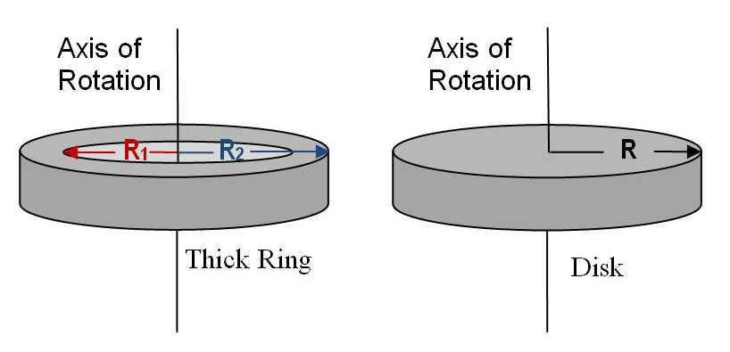

Figure 2: Schematic of rotational axis for ring and disk

**Experiment**

***Setup***

* Use the large rod base and the 45 cm rod to support the Rotary motion sensor as shown in Figure 1.
  + Plug the sensor into the PASCO interface.
  + In PASCO Capstone software, set the sample rate for the Rotary Motion Sensor to 20 Hz.
  + Create a graph of Angular Velocity vs. Time.
* Measure the mass and radii for the disk and ring. Record this data.
* Attach the disk to the clear three-step pulley on the Rotary motion sensor using the thumb-screw.
* Place a level on the disk and level the system using the adjustable feet on the base.

***Procedure***

* Hold the ring with the pins up, so the ring is centered on the disk and 2 to 3 mm above it. [Dropping from too high causes a large vertical force on the bearing which produces a spike in the frictional drag and results in a torque which decreases the angular momentum. However, it is also critical that your fingers are clear of the ring when it strikes the spinning disk.]
* Spin the disk to give it a positive speed of about 30-40 rad/sec. Start collecting data and after about two seconds, drop the ring onto the spinning disk. Continue to collect data for a few seconds more.
* It is difficult to end up with the ring centered on the disk.
  + Measure the minimum distance between the ring and the edge of the disk.
  + Measure the maximum distance directly on the opposite side.
  + The distance “*x*” that the ring is off-center is half of the difference between these two measurements. Record this.
* Use the Coordinates tool to measure the rotational speed of the last data point just before the collision. Record this.
* Measure the rotational speed of the first data point just after the collision. Record this.
* Repeat this procedure at least 5 times. Do analysis for all of these trials.

**Data:**

Record and label data from procedure.

**Computations and Analysis:**

* Use Equation (2) to calculate the initial rotational inertia.
* Use Equation (4) to calculate the final rotational inertia of the ring.
* Calculate the final rotational inertia of the system.
* Use Equation (1) to calculate the initial angular momentum of the system.
* Calculate the final angular momentum of the system and compare with a % error.
* Use Equation (5) to calculate the kinetic energy before and after dropping the ring.

**Conclusions:**

1. Was angular momentum conserved?
2. Was energy conserved? Where did it go?
3. How can angular momentum be conserved and energy not be?

**Sources of errors:**

What assumptions were made that caused error? What is the uncertainty in your final calculation due to measurement limitations?